Robin Users’ Manual
PRELIMINARY

Introduction

Robin represents an easy to use graphical interface for Affymetrix microarray analysis functions from R/BioConductor.

Preconditions and Glossary

Commonly used Terms
Robin helps in evaluating microarrays using advanced normalization strategies and statistics from R/BioConductor. Nevertheless, please bear in mind that most statistics and most normalization techniques make some strong assumption and have some general terminology.
When dealing with microarray, almost always one will deal with values which have been transformed by taking the logarithm to the base of 2. The reason is, that by logging the data, the data becomes roughly normally distributed (Gauss shaped), which then allows using tests, like student’s t-test, making assumption about standard deviations and so forth. Unlogged data is almost always NOT normally distributed, meaning t-tests are NOT applicable (even tough they might still perform reasonably well). Thus, a difference of 1 unit means a two-fold increase or decrease in expression.
Often data is not represented as treatment value and control value, but instead of M and A. Here, M stands for treatment-control (on the log scale, being a division on the normal scale), and A stands for (treatment+ control)/2. So M is a measure of your treatment effect and A of the expression level of that gene.
(Actually another reason for using M and A values is that it is easier to see if values deviate from the zero line as if they were deviating from a line with a slope of one.)

Affymetrix Files

When dealing with Affymetrix chips, you will be confronted with .CEL and .CDF files, the former describes the scanned intensity for every spot (usually there are 2 times ~11 spots per gene). The CDF file describes where the spots for a probe-set are to be found on the chip, since these are not clustered to compensate for local effects such as bubbles, smears, etc.

Assumptions
The strongest assumption probably being, that not much changes in your experiment. I.e. the assumption is that let’s say not more than 5, 10 % of your genes are changing and that thus everything is comparable.
If this assumption is violated, you may not get satisfactory results, or worse wrong results. To demonstrate this issue, just consider the probably oldest, easiest (and obsolete) normalization, namely median centring. Here, one just subtracts the median of one experiment from each data point. In this extreme example, Gene1 and Gene2 are completely switched off.

 | XP1 | XP2
Gene1 | 10.2 | 0
Gene2 | 3.2 | 0
Gene3 | 4.5 | 4.7
Gene4 | 7.8 | 7.9
Gene5 | 9.9 | 9.8
Gene6 | 10 | 10.2
median | 8.85 | 6.3
Table 1: Experiment before normalization

 | XP1 | XP2
Gene1 | 1.35 | -6.3
Gene2 | -5.65 | -6.3
Gene3 | -4.35 | -1.6
Gene4 | -1.05 | 1.6
Gene5 | 1.05 | 3.5
Gene6 | 1.15 | 3.9
Table 2: Experiment after normalization

As and effect, Genes 5 and 6 seem to be upregulated, even though they were unchanged. These effects would disappear in this case, if also some genes were turned on, which often might be the case, but if you have strong suspicions, that very many genes change, and/or that these change in one direction only, you might have to consult statistic counselling.

What does Robin do?
You can use Robin for a
- quality assessment of your Affymetrix data
- normalization of your microarray data
- detection of differentially expressed genes
- preparion of the data for an import into MapMan and/or excel

Using Robin

Firstly, when using Robin, you just have to localize your CEL files. Robin comes preinstalled with a specialized CDF file for Arabidopsis, when dealing with other plants, you will need an internet connection, so Robin can use the Bioconductor framework to install you plant CDF files.
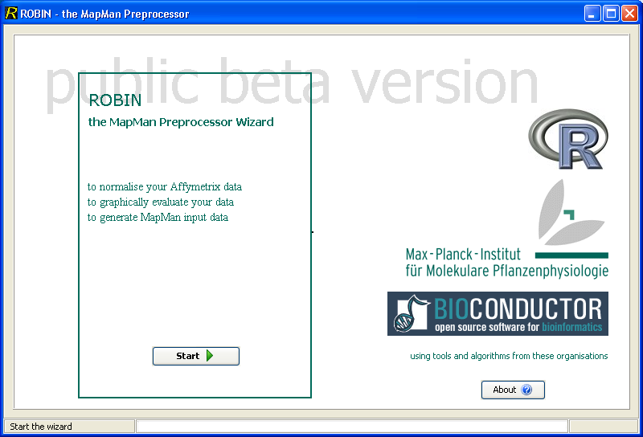
- Startup of Robin
With Robin you are just presented a directory view, and after selecting the directory you can choose which CEL files to use.

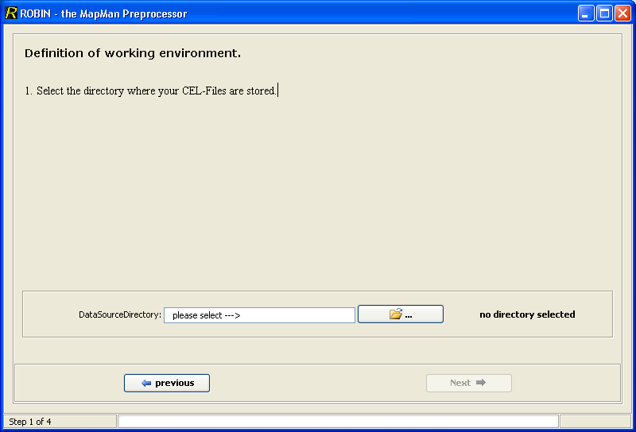
- Defining the working directory
In the directory view, you won’t see your files.
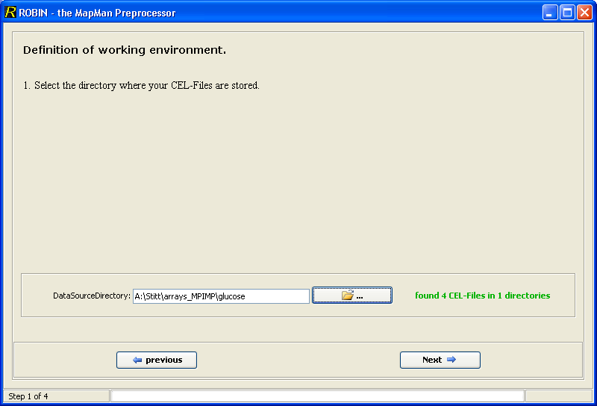
- After definition of working directory

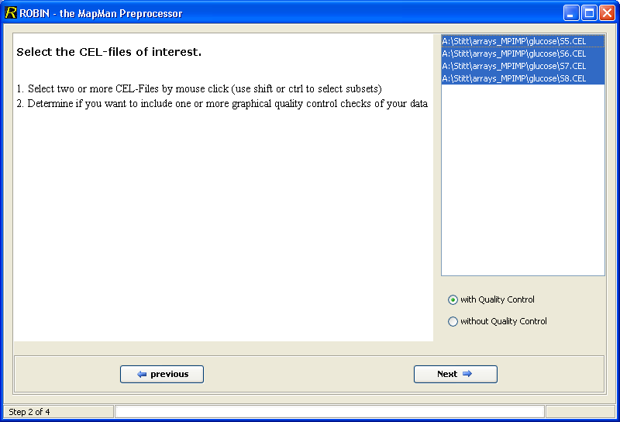
- Selection of CEL Files
After having selected your CEL files, you are presented with various options to investigate into the quality of your array.
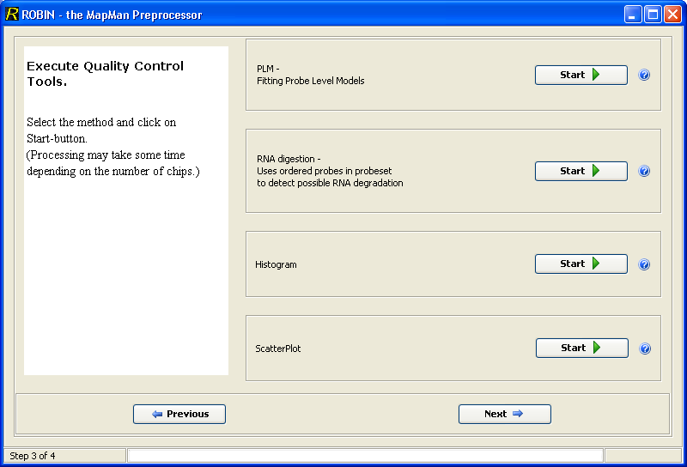
- Quality Control Main Screen
You can choose to generate false colour images of our arrays, boxplots, smoothed histograms, and scatterplots.

Quality Control

False color images of weights:
A linear model is fitted (using RMA style, more later) to your probeset (i.e. your 11 probes), using the boundary, that the effect of all probes in your probeset is zero.
Weights are attached to different probes in your probeset, low weights are coloured in green (i.e. they were not important for the model), and high values in white.
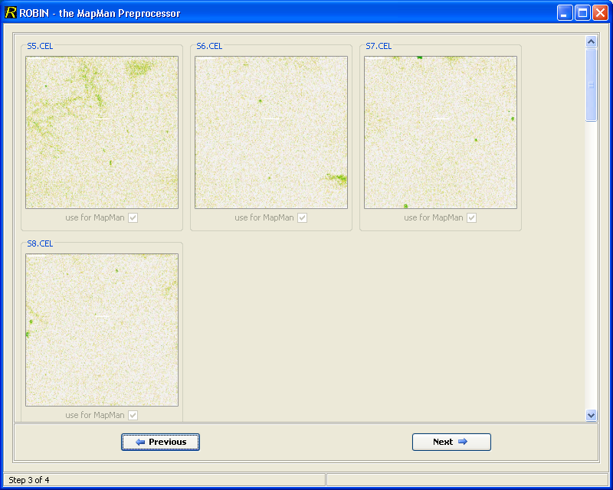
- PLM Weight Image

If you click on an image it gets enlarged to its original size:
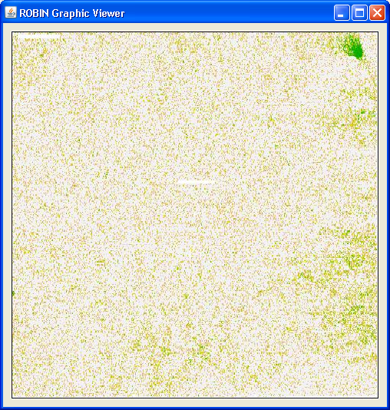
- PLM Weight Image. Here a potential artefact is visible in the upper right corner

For some samples you can have a look at:
http://plmimagegallery.bmbolstad.com/

RNA degradation
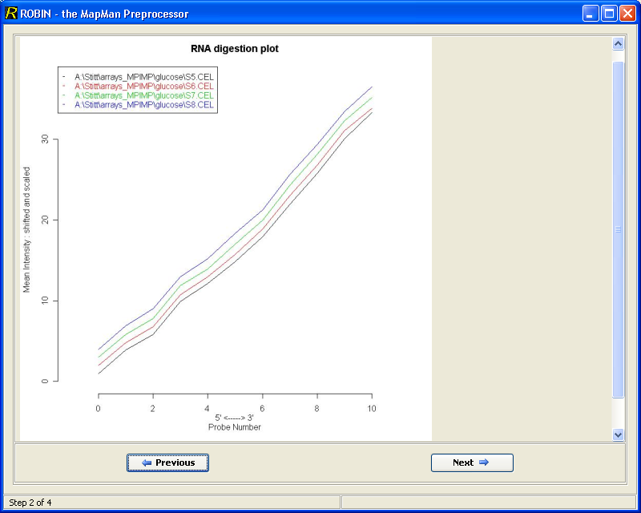
- RNA degradation plot
RNA degradation plots give you an idea about the RNA quality that was used, basically you will look for the slopes of the curves, as these are indicative of differences between 5’ and 3’ ends of transcripts. As your RNA is usually synthesized from 3’->5’ you would expect higher values at the 3’ end.
The height of the curves gives you an indication about the general expression, but this is better investigated with the smoothed histograms (see below). Especially since by default, the curves are staggered (shifted), for visualization purposes.
If you work on barley arrays, it seems to be quite normal, that the curve is kinked on the 3’ most end.

Relative log expression (RLE) plots
Relative log expression compares the expression for each gene on a single chip to the median expression of that gene in all chips. As the assumption is made, that most genes do not change, the plot should be centered around zero and the inter-quartile range (from the top to the bottom of the box) should be small. Deviations from this pattern might indicate bad chips. Alternatively if all “treatment X” chips deviate, this would indicate, that this experiment did indeed cause significant biological changes.

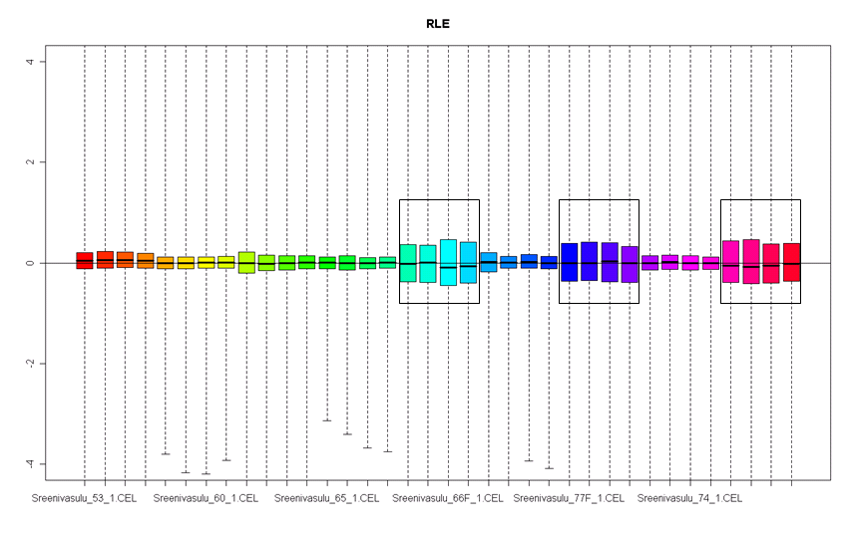
Figure XX, RLE of an experiment identifies 12 chips (boxed) which were harvested from a different tissue.

Normalized unscaled standard error (NUSE) plots
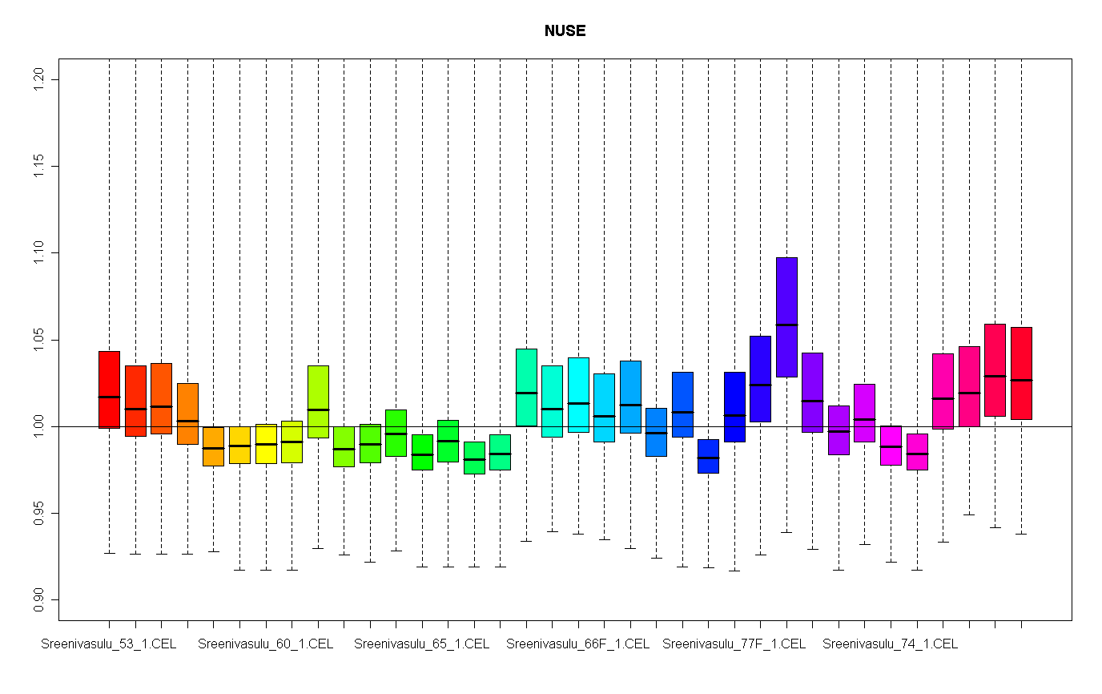
Here the standard error for each gene is measured and the median standard error for each gene, over all arrays is set to one. A higher spread of the standard error or much higher values than 1 might indicate an array of lesser quality. Heber and Sick (2006) suggest the median per array should not be above 1.05 as a rule of thump.

Smoothed histograms
To get an overview of your experiment, you can use the histogram function in Robin. This function shows the frequency of intensities in your chips, before you apply normalization. The curves should look approximately normal distributed, as we already deal with log intensities. All curves should be very similar, if on curve is shifted to the right, it has higher expression, if it is shifted to the left it would have lower expression.
Your curves should also only have one peak!

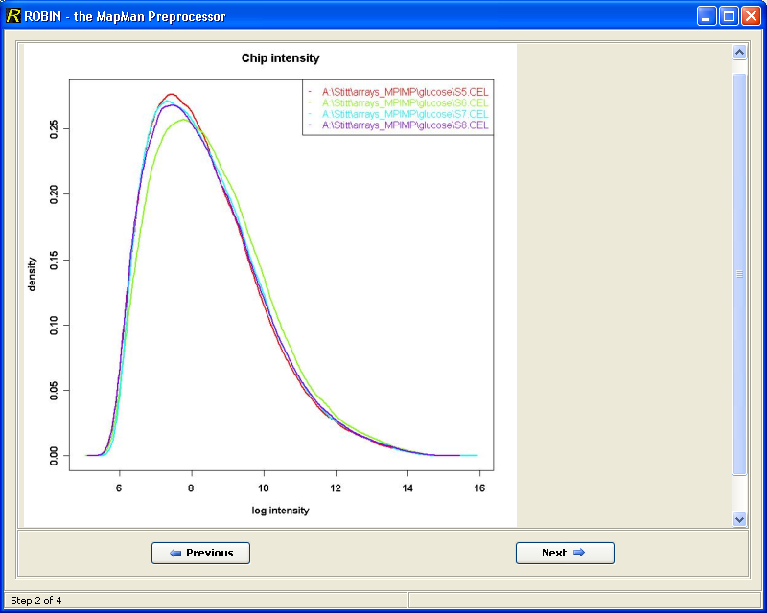
- Smoothed histogram of arrays showing a similar intensity
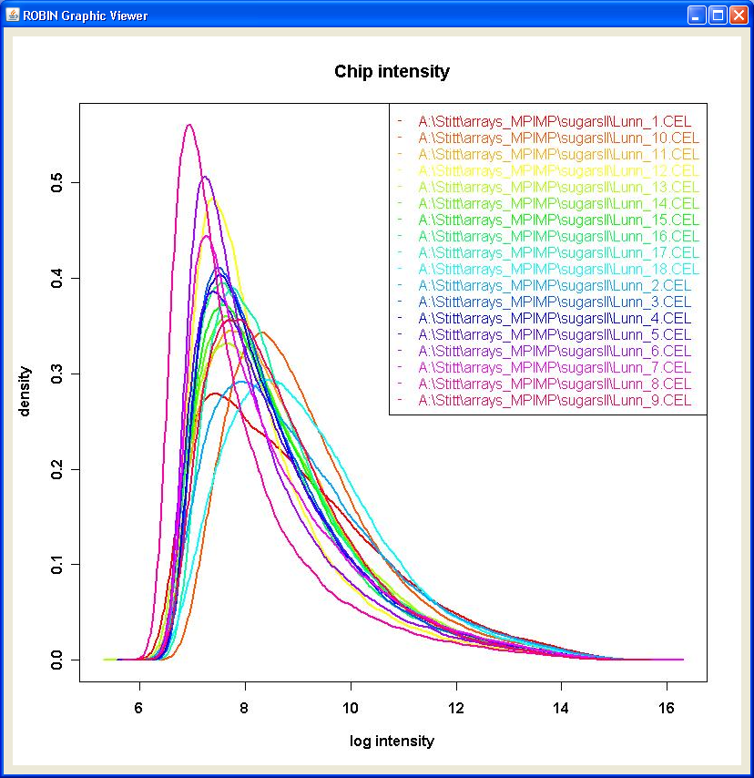
- Smoothed histogram of potentially diverse arrays. Note that some curves are shifted to the right

Scatter Plots
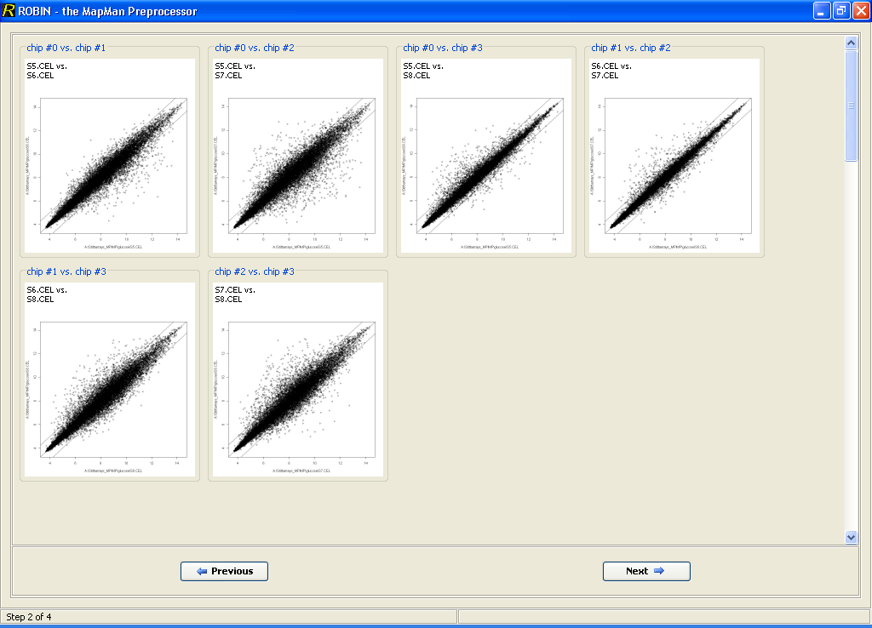
- Scatter Plots of each array against each other

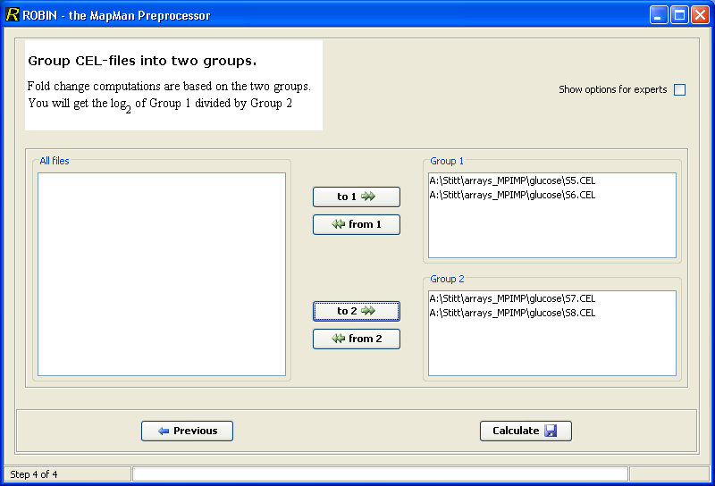
- Determine Class Labels

Normalization
You have several options for normalization, under normal circumstances, Robin uses RMA normalization (which is actually also a form of background correction). gcRMA is a variant of RMA which takes into account GC content, however its advantage over RMA is disputable. MAS5 is the standard algorithm from Affymetrix, it is included for legacy reasons, it is known to perform worse than RMA under normal laboratory conditions when it comes to reproducibility. Its advantage is that it does a “global” normalization, so if you normalized 5 arrays with it and your colleague normalized 10 other arrays you could compare the output values. If you normalize with (gc)RMA the data is fitted to your arrays and you can not compare the expression values with that from another normalization run. You can only compare data (experiments) that have been normalized together. (This might be changing in the future, where you might be able to run a master experiment and fit new data to this experiment).

We recommend RMA normalization.
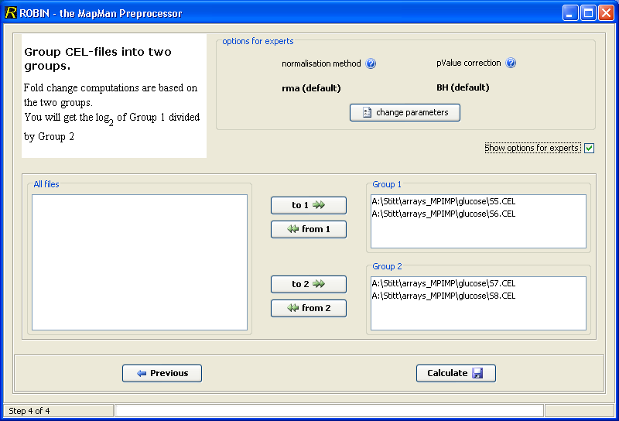
- Advanced Settings

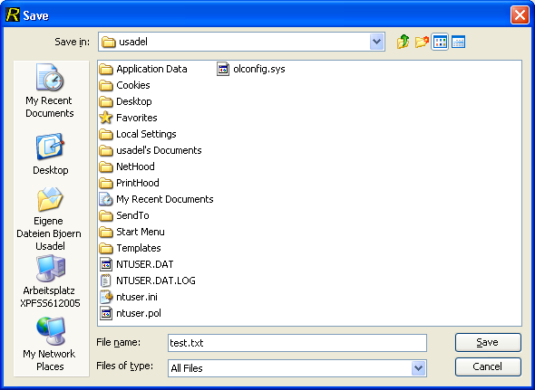
- Output Selection Dialog

Differential Expression of genes
For calculating differential expressed genes, just drag genes into the control and treatment group. Afterwards, a linear model is fitted, and then a moderated t-statistic is calculated for each gene (this is similar but usually more powerful than a normal t-test).
Finally the acquired p-valued can be adjusted using either the false discovery rate controlling methods Benjamini Hochberg or Benjamini Yekutilie, or the more stringent Family wise error rate controlling procedures Bonferroni, Hochberg, Hommel, Holmes.
In the case of the former methods, the “adjusted” p-value that is calculated, represents the false discovery rate if it were used for cut-off, i.e. using p=0.05 as a cut-off means, you would be accepting maximally 5% false positive genes in your list of “differentially” expressed genes. (Even though there might be less or even more than 5% false positives in your actual experiment, as always in statistics that only applies to the average of all your experiments)
Sometimes when dealing with FDR controlled p-values, accepting an FDR rate of 10 or even 20% is common. (Also depending on your question asked, you might even want to allow an FDR of 60-70%, for example if the cost of rejecting a true positive is much higher than having many false negative.)
However, for publication of differentially expressed genes stick to 5 maybe 10, 20 % not more. See e.g. (Nettleton et al., 2006)

 | #declared non significant | #declared significant | Total
#true null | U | V | m0
#non true null | S | T | m-m0
#total | m-R | R | m

Here the FWER is the Probability that V>= 1.

Also ask yourself the question, if what you observe makes sense. Keep in mind that most normalization procedures assume that not much is changing. But if you get 50% observe that 50% of your genes show a differential expression, this assumption was clearly violated. It also happens sometimes, that a lot of genes are called significantly changed (p.adjust<e.g.0.05) but their respective M value (log fold change value) is not very high, let’s say about 0.5 (meaning the fold change is 2^{0.5}= so about 1.41 fold…). In this case you have to decide if such a change can have a biological meaning. However, it has been stated that (affymetrix type) microarrays might underestimate true fold changes (Yuen et al. 2002, Choe et al. 2005).

Still you might only want to consider genes, being (i) called significantly changed and (ii) having an high absolute M value (an M value of -3 is very good as well it represents an 8 fold reduction)

Output
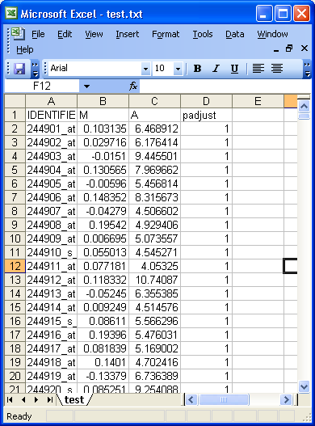
- Exemplary Analysis displayed in MS Excel®

Literature
Nettleton D (2006) A Discussion of Statistical Methods for Design and Analysis of Microarray Experiments for Plant Scientists. Plant Cell 18: 2112-2121

Heber S, Sick B (2006) Quality Assessment of Affymetrix GeneChip Data. OMICS A Journal of Integrative Biology. Volume 10, 358-368

Choe SE, Boutros M, Michelson AM, Church GM, Halfon MS.(2005) Preferred analysis methods for Affymetrix GeneChips revealed by a wholly defined control dataset. Genome Biol. 6(2):R16.

Yuen T, Wurmbach E, Pfeffer RL, Ebersole BJ, Sealfon SC (2002) Accuracy and calibration of commercial oligonucleotide and custom cDNA microarrays. Nucleic Acids Res, ( 30 : e48.

